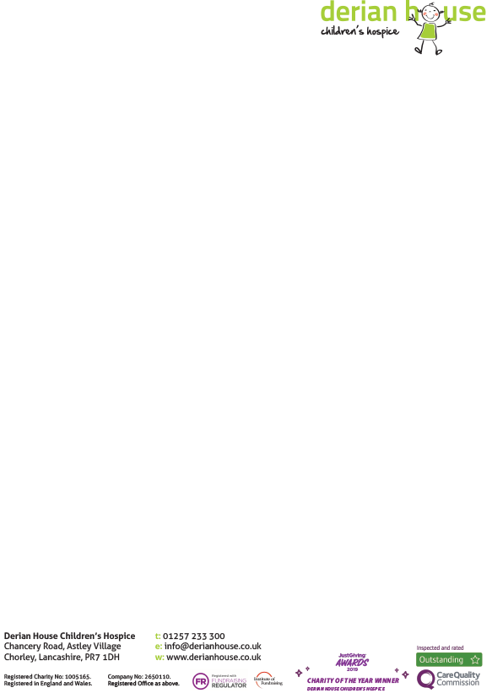

**Self-Exclusion Form**

Derian House will not target you with marketing material at any time during the self-exclusion. We will take steps to remove your name and details from any marketing databases used by ourselves.

We will close any membership of an individual who has entered a self-exclusion agreement and return any funds held in your name.

We have put into effect the following procedures to ensure that anyone who has self-excluded cannot enter our Derian House Raffle.

• A register of those excluded with appropriate records (name, address, and any other appropriate comments).

• Staff training to ensure that staff are able to recognise and enforce the system.

• An individual must take positive action in order to self-exclude by way of a signature.

• The self-exclusion period is a minimum of six months (giving members the option of extending this if they so wish)

• The self-excluded member must take positive action to be removed from the self-exclusion and be able to enter the raffle at a future date.

• Upon notification the player will be given a one-day cooling off period before being allowed access to the Raffle.

• The record of the self-exclusion will remain on file until the agreement has been formally ended.

Please exclude me from your Raffle with immediate effect and do not make any direct contact during my exclusion period:

Name……………………………………………………..

Address…………………………………………………. ………………………………………………….

Donor number (If Known) …………………

Date………………

Signature……………………………………………..

Comments……………………………………………………………… ………………………………………………………………

Please return the form to: - Derian House Children’s’ Hospice, Chancery Rd, Astley Village, Chorley, Lancashire, PR7 1DH or email the completed form to [raffle@derian.co.uk](mailto:raffle@derian.co.uk).